**My New Teacher**

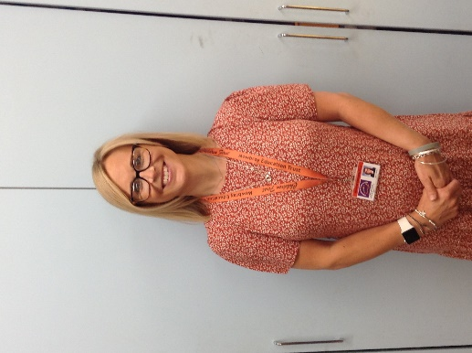I am your new teacher – my name is Mrs Wood

I am looking forward to getting to know you and helping you at school.

I have worked at Sherard for the last 5 years as a teacher in the seahorses classes.

 I love drinking tea 

I have 2 children called Charlie and Olivia and a cat called Archie

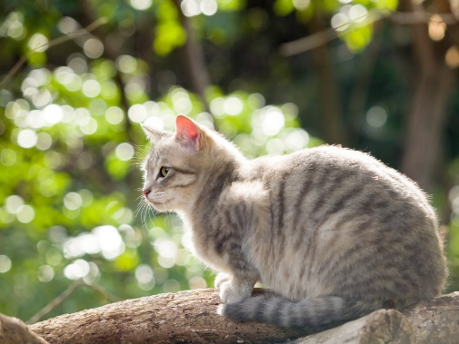

At school we will have lots of fun together and you

will make some new friends



I’m looking forward to having lots of fun with you in your new class!