**My Class Bear**

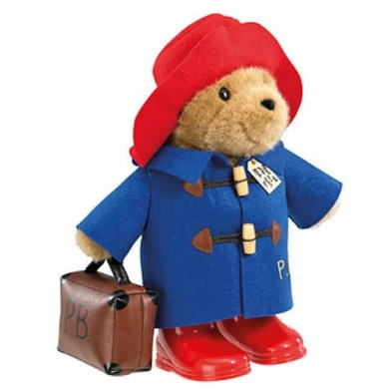I am your new class bear – my name is Paddington!

Once we come back to school, I will be going home with one of the children in the class every weekend.

I am looking forward to having fun with you and doing lots of exciting things.

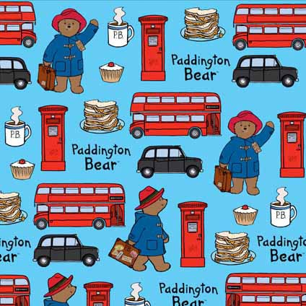

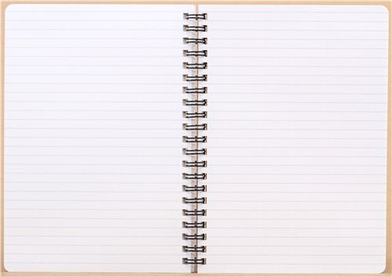I have a special diary for you to put photos and write about all the fun we’ve had to share with all of your friends.

You will bring me and my diary back to school on Monday mornings to share with me and all of your friends in your class.

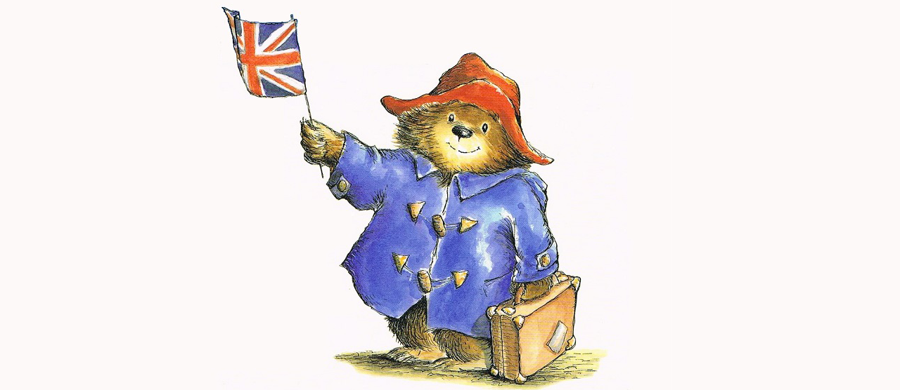

Have a lovely summer and I look forward to seeing you on 25th August!

Mrs Wood xx