**My New Class**

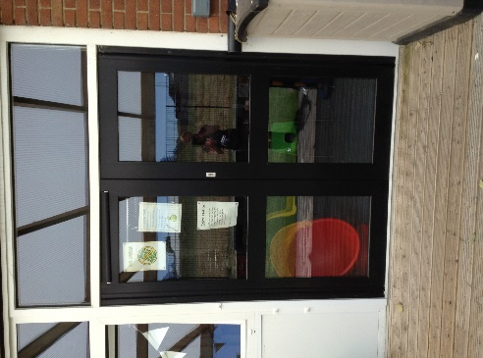Your new class is Purple Seahorses

I am Mrs Wood, your teacher

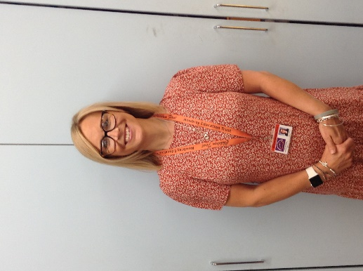

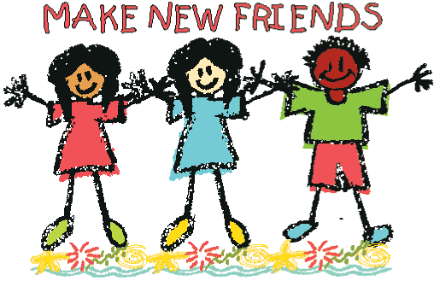

You will spend some time in your new classroom to have fun and make some new friends

There will be some other adults to help you in your new class

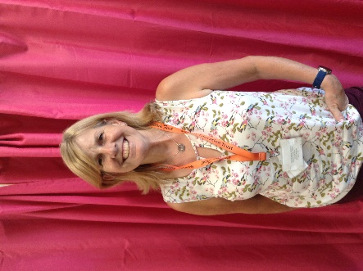

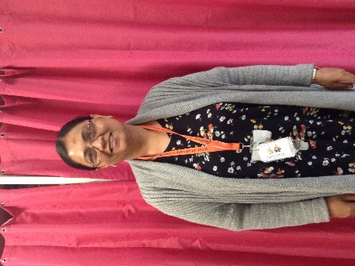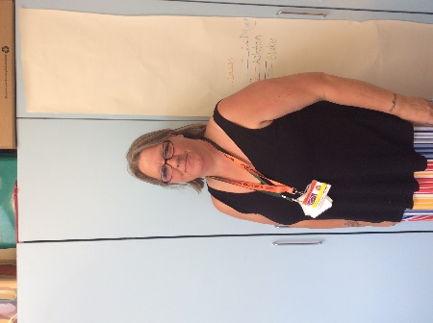

This is This is This is

Mrs Graham Mrs Gardner Mrs Joshi

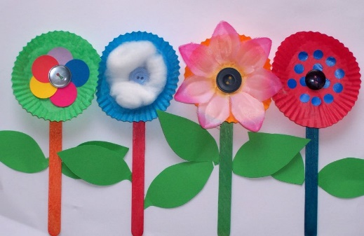We will have lots of fun and do lots of learning together

**You will come back to school on 25th August. We can’t wait to see you!!**