

**Sherard Primary School**

**Transition Booklet**

**PLUM SEAHORSES**

Welcome to Plum Seahorses!

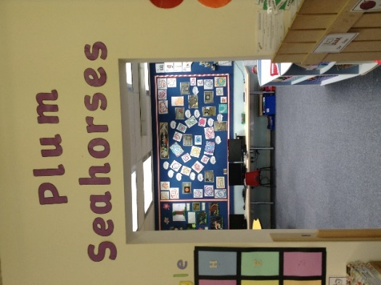

Class Teacher

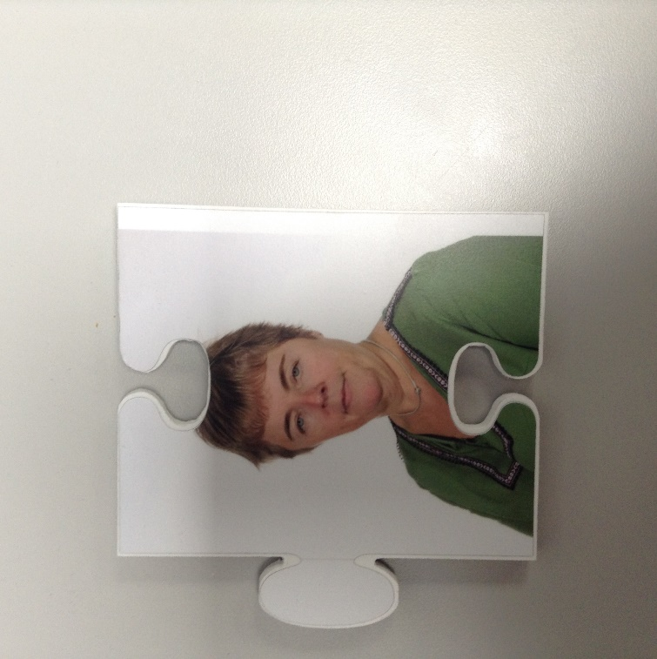

Mrs Cook

**Key Adults**

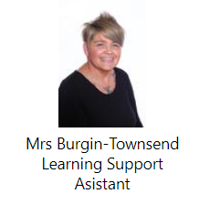

Mrs Kirby

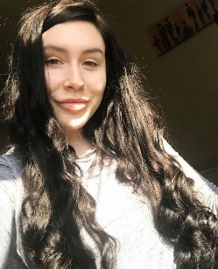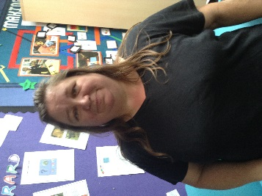

Mrs Grice

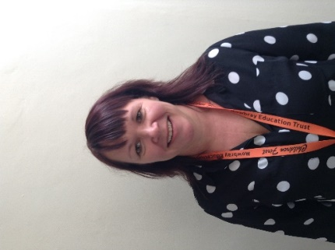

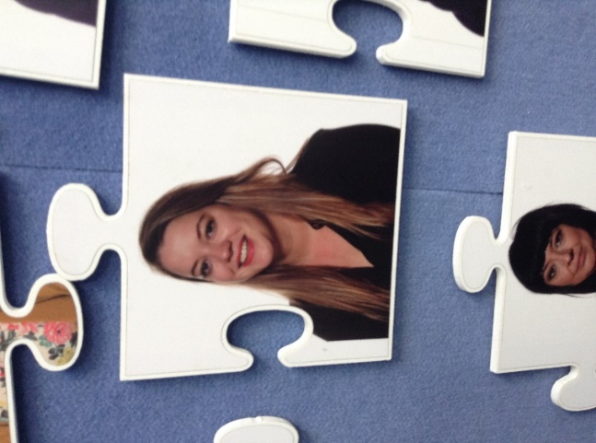

Miss Hynes

Pastoral Manager

Miss Walter

SENCO

This is our class role play area and playing space

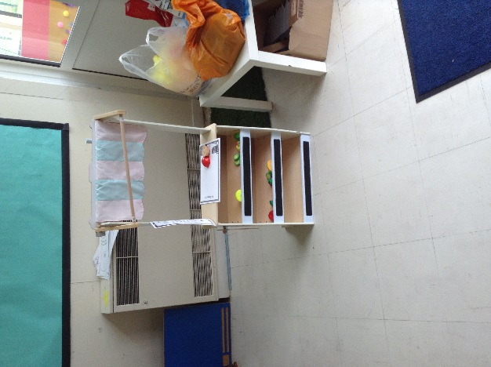

This is where we have carpet time and learn lots of fun things! We have an interactive Whiteboard.

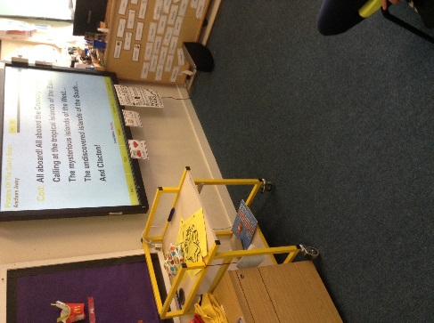

These are the toilets which we use- they are in Purple Seahorses class.

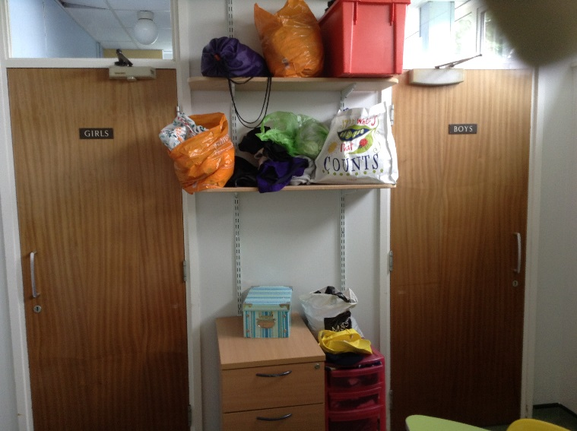

These are our drawers where we keep our things.

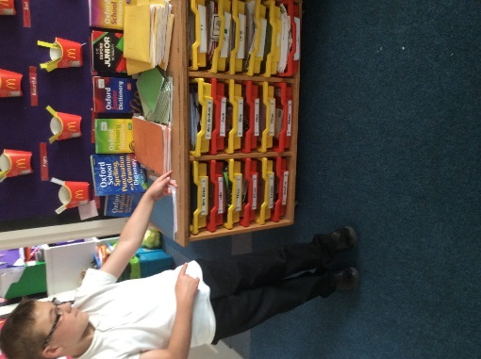

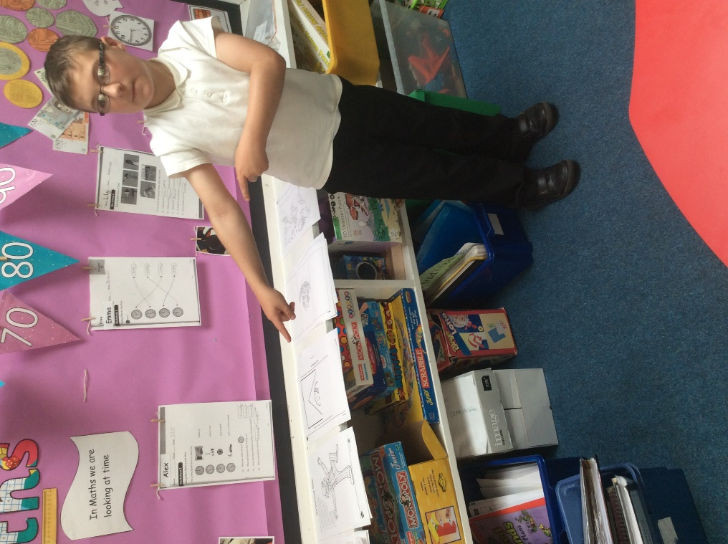These are all of our games which we choose during choosing time!

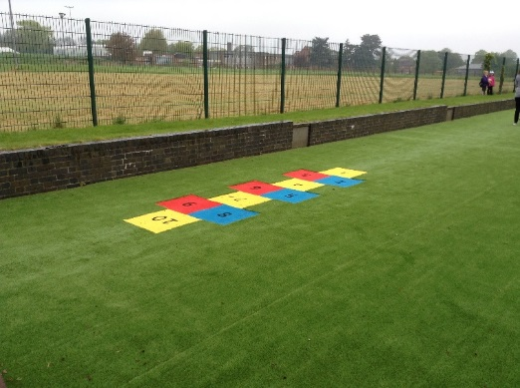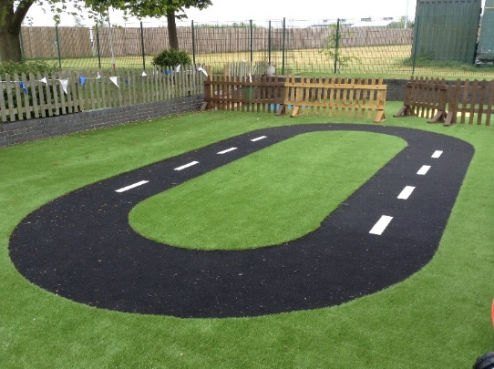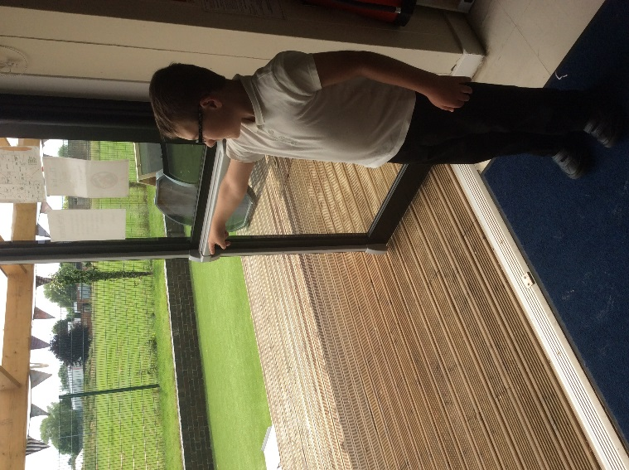This is our outside space, its brilliant! These are the doors which we use when we go out to play.

This is our soft play room

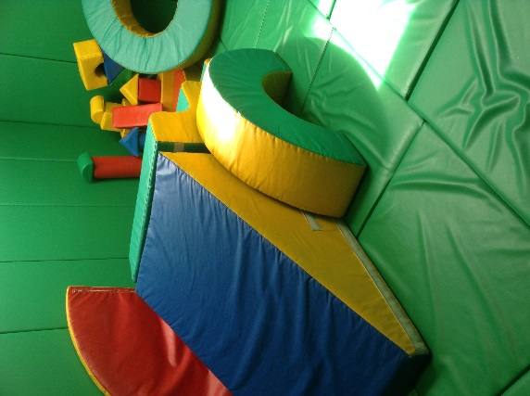

This is our new Sensory Room.

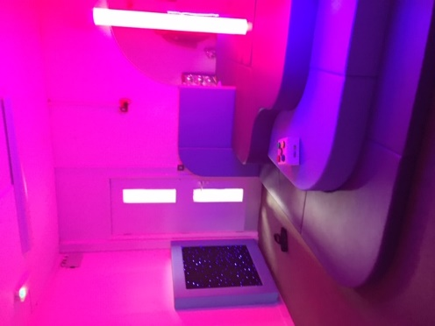

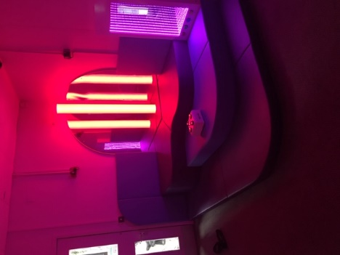

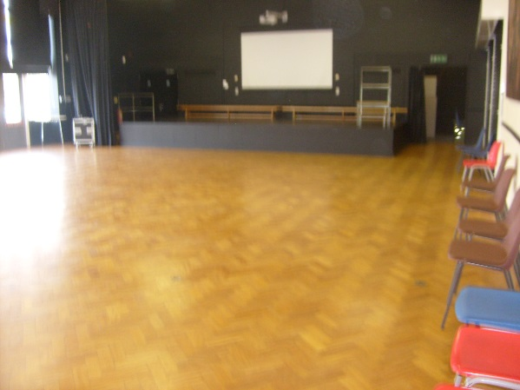This is our Big Hall, we have assembly in here, lunch and games.

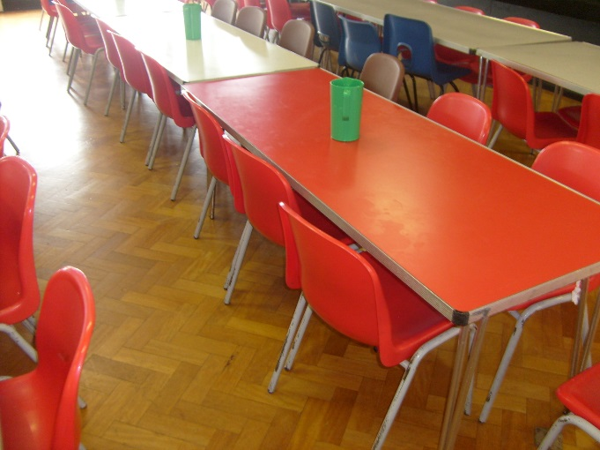These are what the lunch tables look like in the Big Hall but don’t worry we all eat lunch together.

This is the KS2 library where we go sometimes to choose our books!

